Women’s Ministries Initiative: Networking, Educating, Communicating

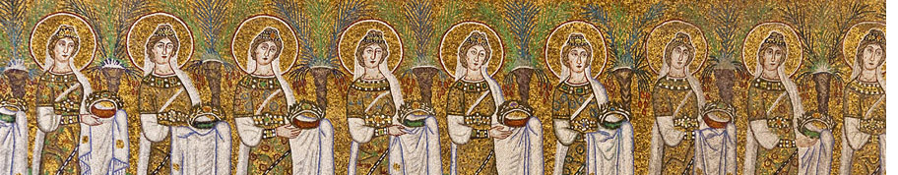

Women and Men in Christ, let us see the Church flourish with positive changes

Women’s Ministries Initiative Pilgrimage to Ely Cathedral
Learning about life and legacy of St Ethelderida of Ely
Registration Form for 4 of March 2017, Ely Cathedral
Full Name.........................................................................................................................
Address................................................................................................................................
Telephone.............................. E-mail...................................................................................
Occupation..........................................................................................................................
Where did you hear about the event?.................................................................................
Please indicate the payment mode and the amount payable to Women’ Ministries Initiative: cash .................. cheque ................. money transfer .................(bank details are provided on request)
The cost of the study day without lunch is £15
Would you like to become a member of WMI?...Y/N
Please indicate if you would like to make a donation to the Women’s Ministries Initiative [please indicate the amount]...........................................................................................
Date........................................... Signature.......................................................................

Please register in advance and send the filled in form and your queries to Dr Elena Narinskaya (Elenarinskaya@yahoo.co.uk) Clare Hall, Herschel Rd, Cambridge, CB3 9AL, UK

